2/8/2024

ELCOT

COMPLETE GST FILE

FOR LAKSHMI MURUGAN GROUP OF COMPANIES

INTRA STATE METHOD

1)PURCHASED GOODS FROM VIMAL (COMPUTER)

HE ALSO FROM TAMIL NADU

FOE 1000000 INVOICE NO M1223HE

2)GOODS SOLD TO MR.INDIA PRIVATE LIMITITES

COMPUTER 100 NOS 11000

PACKGING CHARGE COLLECT FROM THE DEBTORS 10000

ALSO DISCOUNT ALLOWED TO HIM 2 PERCENTAGE .

(REFERANCE NO)= 345643HH

3) HOW TO CLEAR THE ERROR IN TRANSACTION

CREATE ROUGH SALES AND CREAT A WRONG GST AND CLEAR THE MISTAKE

INTER STATE METHOD

1. PURCHASED GOODS FROM VISHNU ANDRAPRADESH
2. COMPUTER 100 NOS 10000
3. INVOICE NO 24RWT355

**SALES TO INTER STATE**

1. SALES 50 COMPUTERS FOE 12000 TO VISHNU IN ANDRA
2. SAME THING AS PURCHASE

**PURCHASE RETURN IN GST**

6)PURCHASED GOODS FROM VIMAL

FOR 60 COMPUTERS 10000

AND RETURN THE COMPUTERS ON 2/4/2023

SO BECAUSE OF DAMAGE .

INVOICE NUMBER 344252YG

**SALES RETURN IN GST**

7)GOODS SALES RETURN FROM VISNU

5 COMPUTERS RETURN BECAUSE OF OTHERS

REF NO : 4352R3TFFY

**INCLUSIVE OF TAX**

HOW CAN WE FIND THE CORRECT AMOUNT OF ITEM IN INCLUSIVE TAX

REF NO 1223GHDV

**FIX GST UNDER GROUP LEVAL**

HARDWARE 18% -USB _8544292

KEYBOARD _84716040

MOUSE_81716060

FURNITURE 18%-TABLE LIGHT LAMP -94055031

DESKTOP TABLE _94036000

STEEL CHAIRS _94017900

PURCHASE MOUSE ,100 NOS 200 RATE

DESKTOP TABLE 100 NOS 200 RATE

INVOICE :35746GH

**IMPORT GOODS FROM OTHER CONTRIES**

1. PURCHASE MOUSE 100 NOS FOR 100 RUPEES
2. HE IS A UNREGISTERD DEALER
3. MAKE AN CORRECT AND MODIFIED GST RATES
4. INVOICE NO :3445FRTT

**HOW TO TANSFER THE AMOUNT IN VAT AND CENVAT IN SGST,CGST**

TRANSFER THE AMOUNT VAT AMOUNT 20000 TO STATE TAX

TRANSFER THE AMOUNT CENVAT AMOUNT 5000 TO CENTAL TAX

**INPUT TAX CREDIT SET OFF**

INPUT TAX CREDIT LIABILITY AMOUNT

CGST-141300 162090

SGST-141300 162090

IGST-73800 39600

**TAX PAYMENT**

TAX PAY TO THE GOVERNMENT

PAY THE ALL TAX TO THE GOVERNMENT BY BANK

**Multiple dealers**

**Composition dealer – has a gst number but will not collect any gst**

**Unregistered dealer – no gst card**

**WE HAVE TO RECORD THE AMOUNT OF GST IN UNREGISTERD DEALER THEN ONLY WE WILL ABLE TO COLLECT THE TAX**

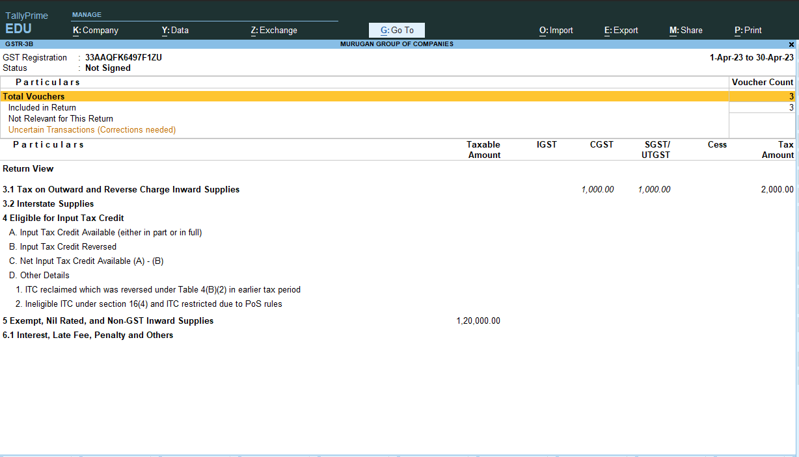

**TRANSFER THAT AMOUNT TO ITC**

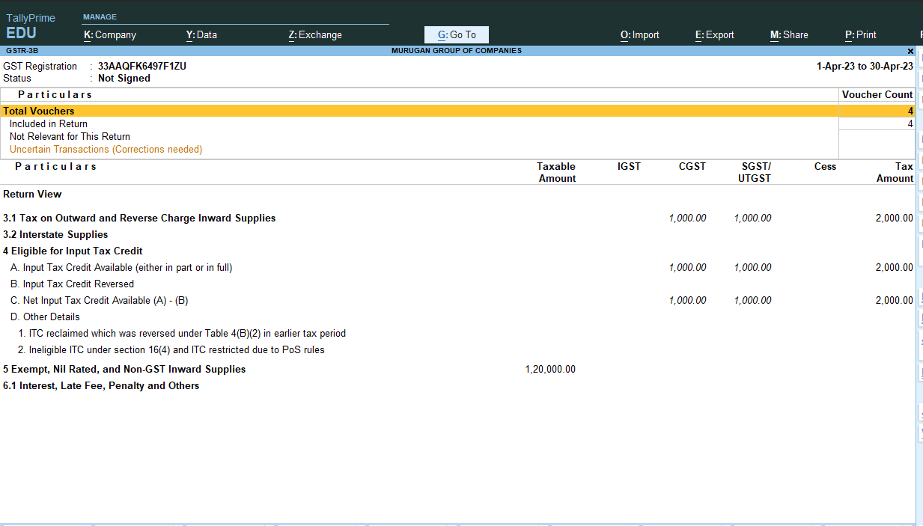

**MONEY TRANSEFERD TO ITC**

**EXPORTS COMPANY**

**HOW TO ENTER THE TRANSACTION IN THE PRIME**

**SALES TO KUMAR IN KANADA**

**MS PRINTER 5 NOS**

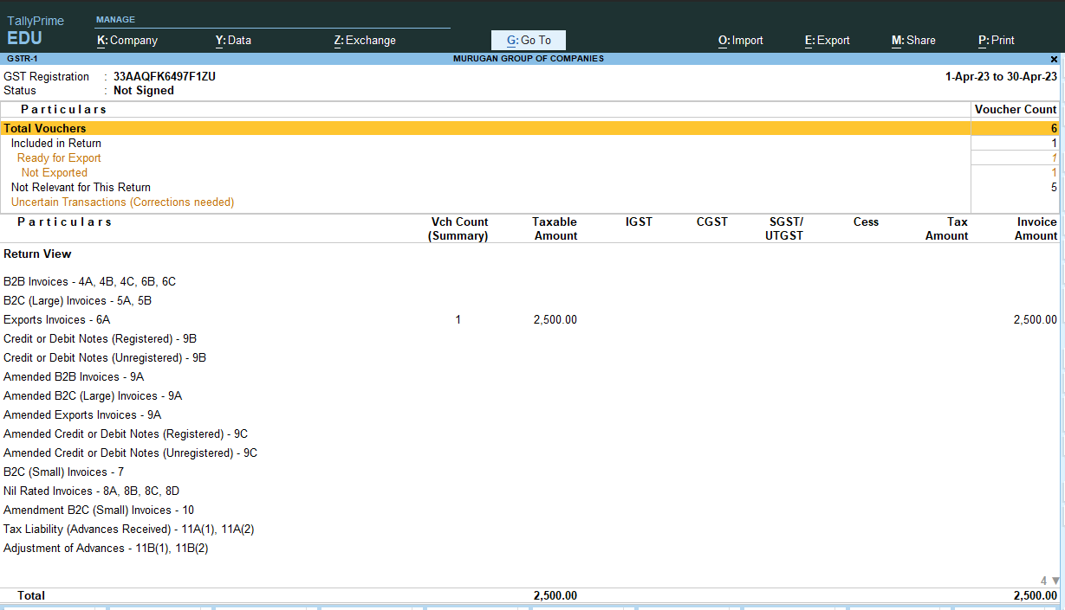

**SALES TO KAMALA IN KANADA WITH TAX**

**MSPRINTER 5**

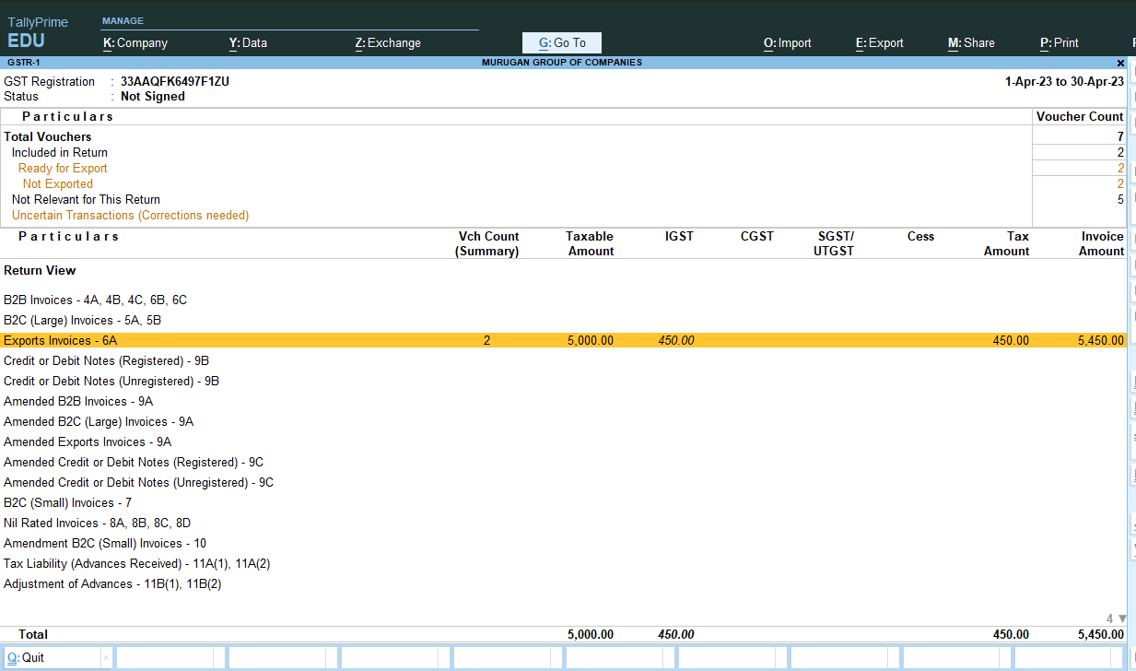

**EXEMPTED GOODS**

**SALES**

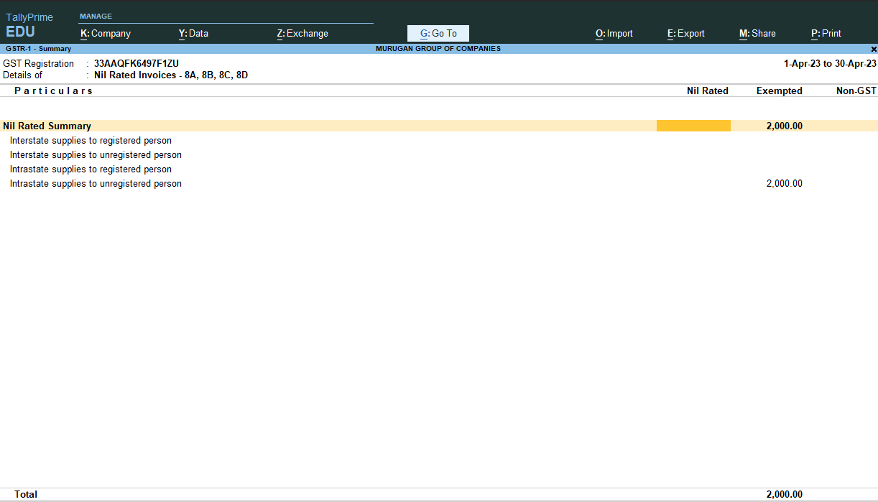

**PURCHASE A EXEMPT IS ALSO A SAME AS SALES**

**SEZ –SALES**

**Same as before**

**Advance receipt tax payment**

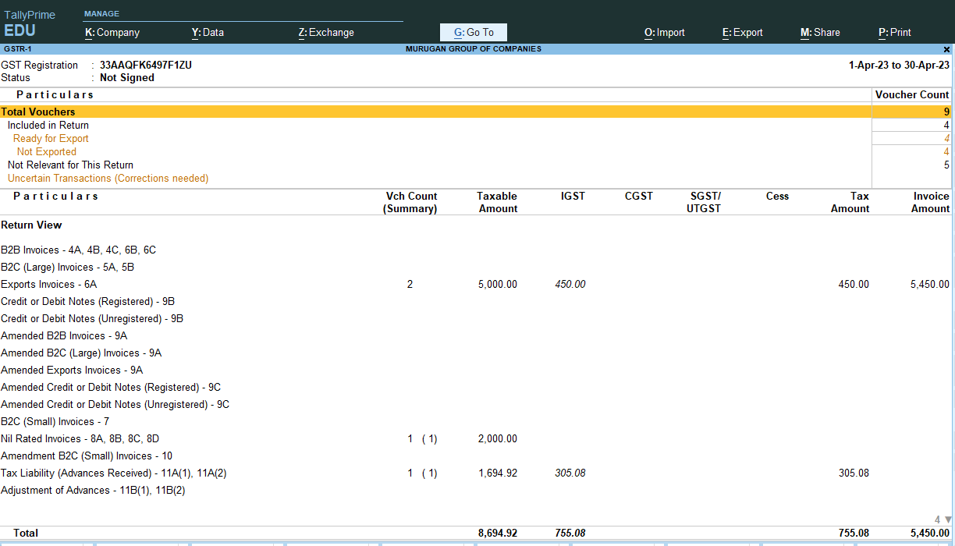

**Advance payment complete by sales**

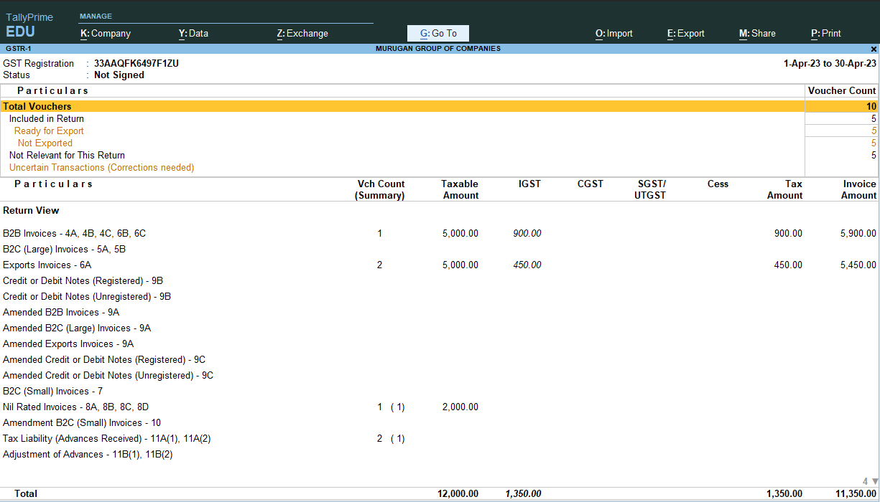

**Advance gives this month but sales next month**

**Leela traders 100000 adavance**

**200 mouse 500 rupees sale on next month**

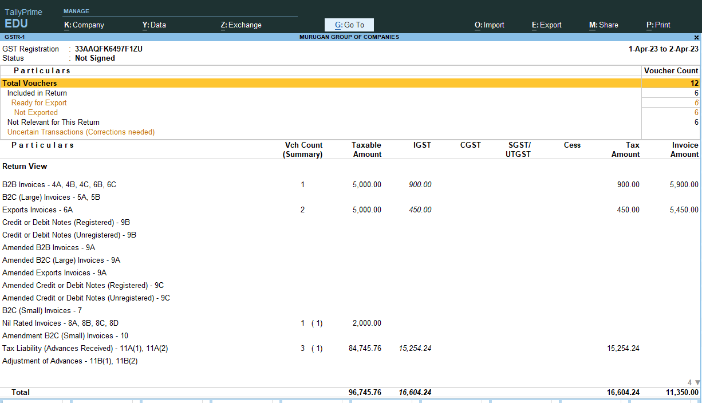

**After clearing this**

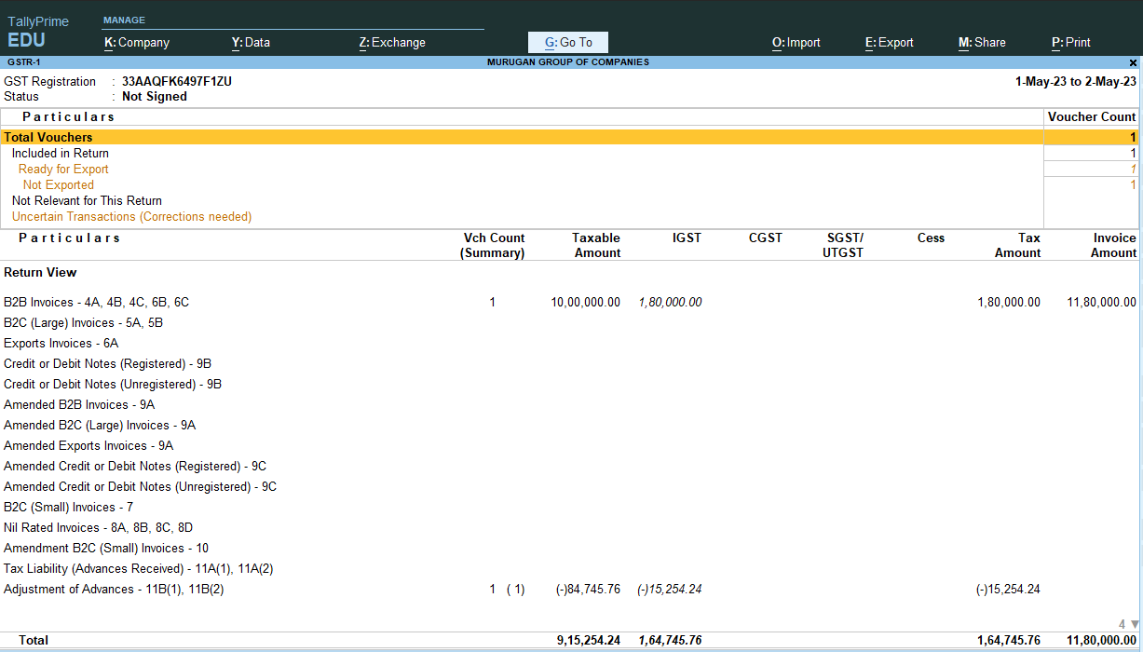

**HOW TO CANCEL THE ADVANCE RECEIPT**

**DEDUCT THE TAX LIABILITY .( REVERS IGST**

**TAX ON ADVANCE )**